國立臺灣海洋大學
資訊工程學系
碩士學位論文
指導教授：賴榮滄 博士
使用直方圖自適應模糊化和空間資訊的影像分割
Image Segmentation Using Histogram Adaptive Fuzzification and Spatial Information
研究生：賴文瑞 撰

中華民國103年6月

使用直方圖自適應模糊化和空間資訊的影像分割

Image Segmentation Using Histogram Adaptive Fuzzification and Spatial Information

研 究 生：賴文瑞 Student：Wen-Jui Lai

指導教授：賴榮滄 Advisor：Zone-Chang Lai

國 立 臺 灣 海 洋 大 學
資 訊 工 程 學 系
碩 士 論 文

A Thesis
Submitted to Department of Computer Science and Engineering
College of Electrical Engineering and Computer Science
National Taiwan Ocean University
In Partial Fulfillment of the Requirements
for the Degree of
Master of Science
in
Computer Science and Engineering
June 2014
Keelung, Taiwan, Republic of China

中華民國103年6月

摘要
在本篇論文中，我們使用了兩個平滑技術加上模糊自適應分群來分割低品質圖像。使用模糊自適應分群來分割圖片，當輸入的影像有較高的雜訊，分割出來的圖片會有較高百分比的分類錯誤。本文提出的方法可以在過程中先消除輸入影像的雜訊再對影像進行分割就可以減少圖片分割後的分類錯誤。從實驗結果來看，建議方法與模糊自適應分群相比，在輸入低於25dB的影像我們得到更好的圖片分割正確率。

關鍵字: 模糊测度、模糊集合、直方圖閾值、影像分割。

ABSTRACT
In this paper, we use two smoothing techniques to segment images with noises. Using fuzzy adaptive clustering [1], the segmented image has high misclassification when the input image has significant noises. The proposed methods can remove the noises of input image and reduce the misclassification of segmented image. From the experimental results, compared with HAF, we can find that the proposed methods can reduce the percentage of error of segmented image when the PSNR of input image is less than 25dB.

Keywords—Fuzzy measures, fuzzy sets, histogram thresholding, image segmentation.

致謝
首先在此要先感謝兩位指導教授 賴榮滄博士及 阮議聰博士 這些日子的指導，從研究題目的發掘及提出、實驗及程式實作的進行、直到論文的撰寫與修改，老師都提供學生許多非常寶貴的建議。而老師除了論文和研究的專業指導外，也教導學生許多做人做事的道理，以及開拓了我許多的視野以及眼界，在此感謝老師的指導。也在此感謝口試委員 阮議聰博士、黃崇仁博士、廖怡欽博士 對學生及本論文的指導及指教。
也在此感謝308實驗室的學長姐、同學及學弟妹們：承翰、仁傑、祈龍、勝滄、宗荃、亭忠、氏雲，和大家一起討論及分享課業上及生活上的點點滴滴。

目錄
摘要 I
ABSTRACT II
致謝 III
目錄 IV
Chapter 1 Introduction 1
1.1 Background 1
1.2 Motivation 1
1.3 Organization 2
Chapter 2 Histogram Adaptive Fuzzification 3
2.1 Introduction to the Fuzzy Set 3
2.2 Related Work 4
2.3 Algorithm of the Histogram Adaptive Fuzzification 5
Chapter 3 Proposed Method 7
3.1 Introduction to the Proposed Method 7
3.2 Algorithm of the Proposed Method 7
Chapter 4 Experimental Results 9
4.1 Performance Measure 9
4.2 The First Example 10
4.3 The Second Example 13
4.4 The Third Example 16
Chapter 5 Conclusion 20
REFERENCES 21

List of Table
TABLE 1: percentage of error of reference image 11
TABLE 2: percentage of error of blood image 14
TABLE 3: percentage of error of bacteria image 17

List of Figures
Fig 1. A Typical S-function. 4
Fig 2. Histogram of "Lena" image and initial fuzzification. 5
Fig 3. Reference image. 11
Fig 4. Performances of the proposed method and HAF. 11
Fig 5. (a) test image 1, (b) segmentation image using HAF, (c) segmentation image using the proposed method with 3×3 mean filter, (d) segmentation image using proposed method with the 3×3 median filter. 12
Fig 6. (a) test image 2, (b) segmentation image using HAF, (c) segmentation image using the proposed method with 3×3 mean filter, (d) segmentation image sing proposed method with the 3×3 median filter. 12
Fig 7. (a) test image 3, (b) segmentation image using HAF, (c) segmentation image using the proposed method with 3×3 mean filter, (d) segmentation image sing proposed method with the 3×3 median filter. 13
Fig 8. blood image. 14
Fig 9. (a) blood image 1, (b) segmentation image using HAF, (c) segmentation image using the proposed method with 3×3 mean filter, (d) segmentation image using proposed method with the 3×3 median filter. 15
Fig 10. (a) blood image 2, (b) segmentation image using HAF, (c) segmentation image using the proposed method with 3×3 mean filter, (d) segmentation image using proposed method with the 3×3 median filter. 15
Fig 11. (a) blood image 3, (b) segmentation image using HAF, (c) segmentation image using the proposed method with 3×3 mean filter, (d) segmentation image using proposed method with the 3×3 median filter. 16
Fig 12. bacteria image. 17
Fig 13. (a) bacteria image 1, (b) segmentation image using HAF, (c) segmentation image using the proposed method with 3×3 mean filter, (d) segmentation image using proposed method with the 3×3 median filter. 18
Fig 14. (a) bacteria image 2, (b) segmentation image using HAF, (c) segmentation image using the proposed method with 3×3 mean filter, (d) segmentation image using proposed method with the 3×3 median filter. 19
Fig 15. (a) bacteria image 3, (b) segmentation image using HAF, (c) segmentation image using the proposed method with 3×3 mean filter, (d) segmentation image using proposed method with the 3×3 median filter. 19

Chapter 1 Introduction

1.1 Background
In computer vision, image segmentation is the process of partitioning a digital image into multiple segments. In many image analysis applications, image segmentation can identify the regions of interest in a scene. The goal of segmentation is to simplify image into something that is more meaningful and easier to analyze. Some of the practical applications of image segmentation, for example, face recognition[2] and fingerprint recognition [3].
There are many methods available for segmentation, for example, the k-means algorithm [4, 5] and histogram based methods[6]. The k-means algorithm partitions an image into k clusters; while the histogram-based methods use the peaks and valleys of histogram to determine thresholds for segmenting images. Algorithms using fuzzy techniques for image segmentation are based on finding the optimum threshold of image histogram through minimizing the fuzzy entropy or the index of fuzziness [7, 8]. Histogram adaptive fuzzification (HAF) [1] is a simple image segmentation methodology using adaptive fuzzification on gray level histogram. HAF determines threshold based on the intersection of two linguistic variables modeled by two fuzzy subsets calculated adaptively using the gray level histogram. Finally, two fuzzy subsets which are called object-subset and background-subset are determined. The proposed approach does not attempt to detect a global optimal threshold; hence, the risk of getting blocked in a local minimum is avoided.

1.2 Motivation
Because of the limitations of the image capture, transmission and receive equipment, images are often corrupted by a variety of noise. The Gaussian white noise and salt and pepper noise models are often used in conjunction to describe the observation of the actual image noise. It is noted that the HAF faces the noises problem. That is, a segmented image has high percentage of error when the quality of input image is low. To solve this high percentage of error, we may remove the image noises for HAF.

1.3 Organization
This paper is organized as follows. In Section II, a review on histogram adaptive fuzzification is presented. In Section III, the proposed method is presented. Section IV shows comparative results to illustrate the effectiveness of the proposed approach and Section V presents the final conclusions.

Chapter 2 Histogram Adaptive Fuzzification

2.1 Introduction to the Fuzzy Set
Zadeh proposed fuzzy set theory in 1965 [9]. This theory uses the membership function to assign each element with a membership grade, which is in the interval [0, 1]. Let X be the universe of discourse with a generic element denoted by x_{i}. That is, X = {x₁, x₂,.., x_{m}}. A fuzzy set is formally defined as
A = {(x_{i}, μ_{A}(x_{i}))}, x_{i}∈X (1)
where μ_{A} is called the membership function or characteristic function and each point x_{i}∈X is assigned by a membership grade μ_{A}(x_{i}) ∈ [0, 1]. For image segmentation, fuzzy subsets are modeled corresponding to crisp object subset O with Z-function and background subset B with S-function. S-function is defined as:
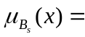S(x; a_{s}, b_{s}, c_{s}) = 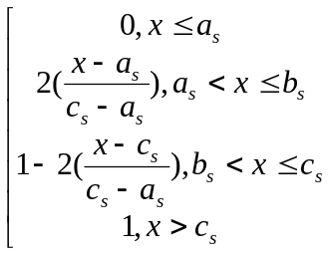 (2)
The S-function is controlled by the parameters a_{s} and c_{s}. Note here that b_{s} is the crossover point, given by b_{s} = (a_{s} + c_{s})/2. A typical shape of the S-function is presented in Fig. 1. The Z-function used to model object subset O is defined as follows:
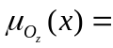Z(x; a_{z}, z_{z}, c_{z}) = 1- S(x; a_{s}, b_{s}, c_{s}) (3)
We initialize the subsets O and B using the histogram intervals [x_{min}, x_{i}] and [x_{j}, x_{max}], respectively, where x_{i} and x_{j} are two gray values, which are used to determine subsets O and B in the initialization process. The initial parameters of the S- and Z-functions are calculated based on their histogram intervals [10]. The procedures of determining the parameters of the S- and Z-functions are given in the following section.
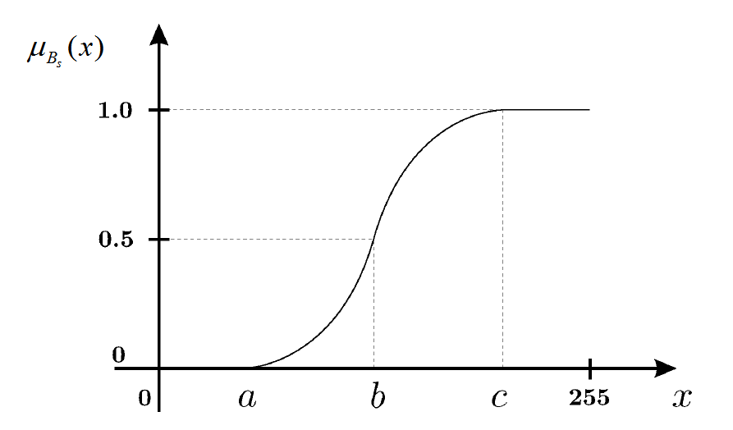
Fig 1. A Typical S-function.

2.2 Related Work
HAF (histogram adaptive fuzzification) is used to divide the histogram into two crisp subsets: object subset O and background subset B. These two subsets are located at the beginning and the end regions of the histogram as shown in figure 2. In this algorithm, subsets B and O are initialized first. Next, a seed is added to the current subset repeatedly, where a seed is a gray value. The seed is picked from fuzzy region, which is placed between subsets O and B as shown in Fig. 2. After a new current subset is generated, the parameters of the S and Z-functions should be updated. The parameters of the S and Z-functions are determined as follows:
b = (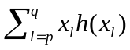)/(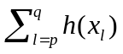) (4)
c = b + max{⎟b-x_{max'}⎟), ⎟ b-x_{min'}⎟} (5)
a = 2b – c (6)
where denotes the histogram value of gray level x_{l}; and p and q are the limits of gray levels in the current subset O∪{x_{i}} or B∪{x_{j}}. The quantities x_{max'} and x_{min'} are the maximum and minimum gray levels in the current subset for which h(x_{max'}) ≠ 0 and h(x_{min'}) ≠ 0. The crossover point b in equation (4) is the mean gray level value of the interval [x_{p}, x_{q}]. Note that a and c are obtained using equations (6) and (5). Using the current subset B, the parameters a_{s}, b_{s}, and c_{s} are obtained using equations (6), (4), and (5), respectively. Similarly, a_{z}, b_{z}, and c_{z} are obtained using the subset O. The S and Z-functions are updated using the set elements.
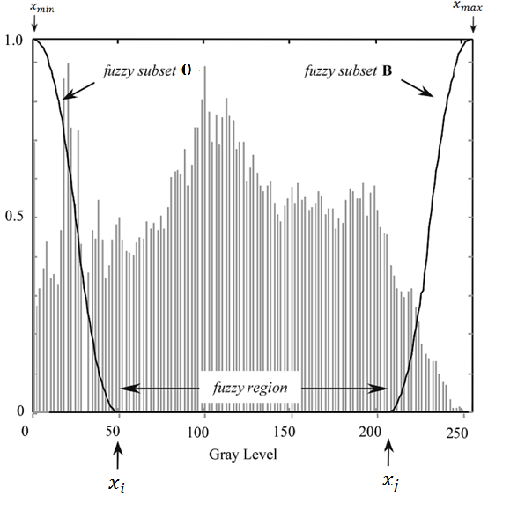
Fig 2. Histogram of "Lena" image and initial fuzzification.

2.3 Algorithm of the Histogram Adaptive Fuzzification
At this stage, the histogram adaptive fuzzification algorithm (HAF) is presented below:
Histogram Adaptive Fuzzification Algorithm
(1) Input a test image, and the values of i and j. Initialize subsets O and B using the histogram intervals [x_{min}, x_{i}] and [x_{j}, x_{max}].
(2) Set 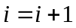 and j = j – 1.
(3) Update current subsets B = B ∪ {x_{j}} and O = O ∪ {x_{i}}.
(4) Calculate parameters (a_{s}, b_{s}, c_{s}) and (a_{z}, b_{z}, c_{z}) with the subsets B and O using equations (4), (5), and (6).
(5) Repeat steps (2), (3), and (4) until a_{s} ≤ c_{z}.
(6) Output a_{s} and c_{z}.
In the step (1), x_{min} and x_{max} are the minimum and maximum gray levels of an image; and x_{i}, and x_{j} are two gray values used to initialize subsets O and B. After determining a_{s} and c_{z}, the threshold: th used to segment an image is obtained by the following equation:
th = (a_{s} + c_{z})/2 (7)

Chapter 3 Proposed Method

3.1 Introduction to the Proposed Method
HAF segments image using the information of histogram. The histogram consists of the number of pixels for each gray level. It lacks spatial information. That is, a pixel may be classified into wrong region using the threshold obtained through equation (7), especially for a noisy image. Using HAF, misclassification is increased significantly, when the PSNR of a noisy test image is less than 25dB [1]. To solve this problem, we first use a filter of 3 × 3 to provide spatial information and improve the quality of a test image, then HAF is applied to the filtered image. The 3 × 3 median and mean filter are used in this paper to reduce noises in an input image. The experimental results show that the proposed method can provide the much higher segmentation accuracy compared with HAF. Note here that the 3 × 3 median filter has the better property of preserving edges especially for “speckle” noise or "salt and pepper" noise.
The values of x_{i} and x_{j} for HAF should be given by the user. To release this burden, we set x_{i} = x_{min} + itvr and x_{j} = x_{max} - itvr. In this paper, we set itvr = 5, since we find that itvr = 5 will give a good performance from our experiments. For the proposed method, the initial subsets B and O are obtained as: O = {x_{min}, x_{min+1}, x_{min+2},… , x_{i} } and B = {x_{j}, x_{j+1}, x_{j+2},… , x_{max}}. The threshold th used to segment an image is obtained by the same method as HAF. Finally, a pixel is classified as a background pixel, if its gray level is less than th. If gray level is larger than or equal to th, then this pixel is classified as an object pixel, for a light background case. At this stage, we would like to present the proposed method as follows.

3.2 Algorithm of the Proposed Method
Proposed Method
(1) Input a test image and pass the image through a 3×3 mean or median filter.
(2) Determine x_{min} and x_{max} and generate the values of x_{i} and x_{j}. Set subsets O = {x_{min}, x_{min+1}, x_{min+2},… , x_{i} } and B = {x_{j}, x_{j+1}, x_{j+2},… , x_{max}}.
(3) Set and j = j – 1.
(4) Update subsets B = B ∪ {x_{j}} and O = O ∪ {x_{i}}.
(5) Calculate parameters (a_{s}, b_{s}, c_{s}) and (a_{z}, b_{z}, c_{z}) with the subsets B and O using equations (4), (5), and (6).
(6) Repeat steps (3), (4), and (5) until a_{s} ≤ c_{z}.
(7) Output th = (a_{s} + c_{z})/2.
(8) For each pixel of the test image, for a light background case: if its gray level < th, classified the pixel as a background pixel; otherwise, classified the pixel as an object pixel.
(9) Output the segmented image.

Chapter 4 Experimental Results

4.1 Performance Measure
The percentage of error for a segmented image is used as the performance measure in this paper. For a segmented image of X×Y pixels, the percentage of error is defined as:
P(error) = (1 - ⏐R₁∩R₂⏐/XY) × 100 (8)
where _{R1} and 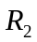 are the set of pixels in reference and segmented images, respectively, and |.| is the cardinality of the set. P(error) varies from 0% for a perfect output image to 100% for a totally wrong output image.
The test images are generated through adding noises to a noise free image, which is referred to as the reference image. Two kinds of noise: "Gaussian" and "salt and pepper" are used in this paper. The peak signal-to-noise ratio (PSNR) is used to measure the degree of a test image is degraded from a reference image. The peak signal-to-noise ratio (PSNR) is defined below.
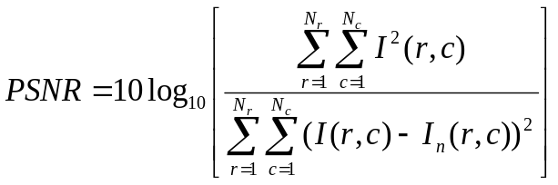 (9)
where 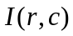 and 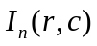 represent the gray levels at the (r, c)th pixel of the reference and test images of 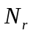×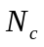pixels, respectively. A reference image, as shown in figure 3, is used to generate various test images through adding salt and pepper noises to it. The percentages of error for the proposed method and HAF are shown in figure 4. From figure 4, the proposed method with median filter has the best performance, in terms of percentage of error. The proposed method has the much lower percentage of error than HAF, when the PSNR of a test image is low. For a test image having PSNR = 9 dB, the proposed method with the median filter can reduce the percentage of error of HAF by 76.6%. For a test image with PSNR higher than 28 dB, the percentages of HAF and the proposed method are almost the same.

4.2 The First Example
To evaluate the performances of the proposed method and HAF subjectively, three test images: 1, 2, and 3 for the first example, are generated through adding Gaussian white noise and salt and pepper noise to the reference image shown in figure 3. The mean values and standard deviations of Gaussian white noise for test images 1, 2, and 3 are {0, 0.01}, {0, 0.02} and {0, 0.03}. The noise density of salt and pepper noise for test images 1, 2, and 3 are 0.05, 0.06 and 0.07. The PSNRs of test images 1, 2, and 3 are 19.7 dB, 17.7 dB, and 16.7 dB, respectively. The segmented images of test images 1, 2, and 3 using the proposed method and HAF are presented in figures 5, 6, and 7, respectively. From these figures, we can find that HAF obtains the worst segmentation images and the proposed with 3×3 median filter has the best segmentation results. From figures 5 to 7, we can find that the proposed method and HAF obtain the worst segmentation result using test image 3. This is due to the PSNR of test image 3 is the smallest, which implies that test image 3 has the worst image quality. From figure 7(b), we can conclude that the segmented result of test image 3 is unacceptable. Table 1 gives that the percentages of error for segmented results of test images 1, 2 and 3 using the proposed method and HAF. From table 1, we can that the percentage of error for the segmented result of test image 3 using HAF is pretty high (about 27.51%), which indicates a bad segmented image. Compare with HAF, the proposed method with median filter can reduce the percentage of error by about 92% to 95%.

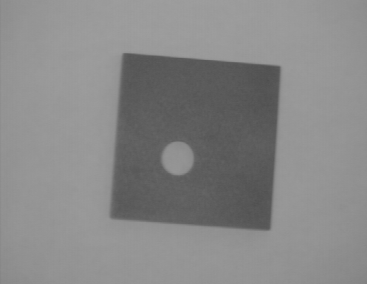
Fig 3. Reference image.

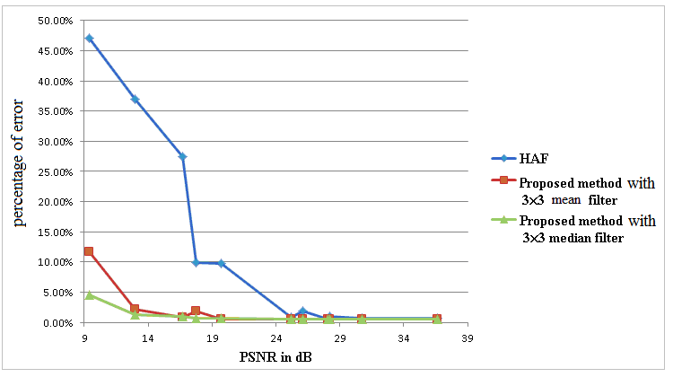
Fig 4. Performances of the proposed method and HAF.

TABLE 1: percentage of error of reference image
 | test image 1  (PSNR = 19.7) | test imaged 2  (PSNR = 17.7) | test image 3  (PSNR = 16.7)
Histogram adaptive fuzzification | 9.7067% | 9.9363% | 27.5057%
Proposed method with  3×3 mean filter | 0.5905% | 1.8633% | 0.8059%
Proposed method with  3×3 median filter | 0.6859% | 0.7011% | 0.9374%

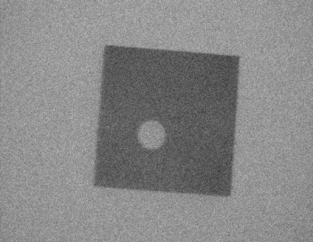
(a)
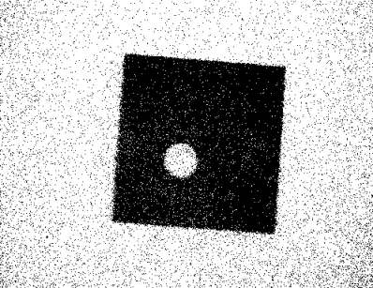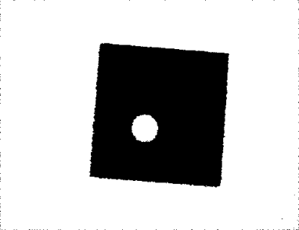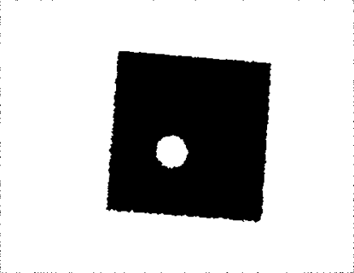
(b) (c) (d)
Fig 5. (a) test image 1, (b) segmentation image using HAF, (c) segmentation image using the proposed method with 3×3 mean filter, (d) segmentation image using proposed method with the 3×3 median filter.
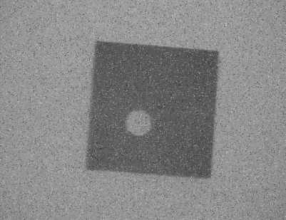
(a)
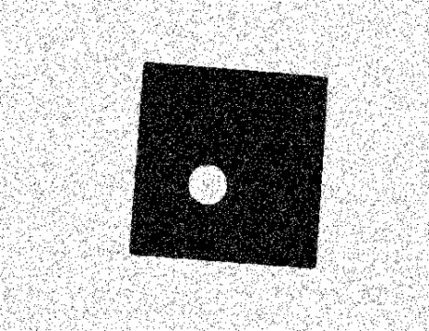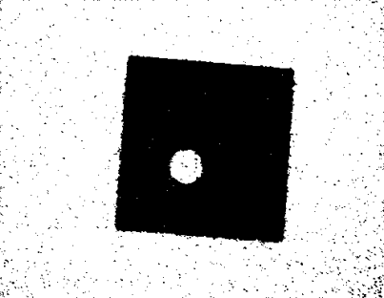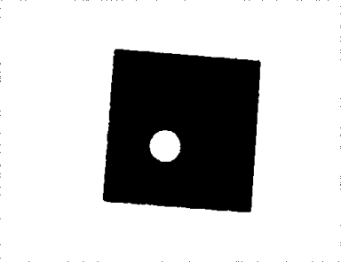
(b) (c) (d)
Fig 6. (a) test image 2, (b) segmentation image using HAF, (c) segmentation image using the proposed method with 3×3 mean filter, (d) segmentation image sing proposed method with the 3×3 median filter.

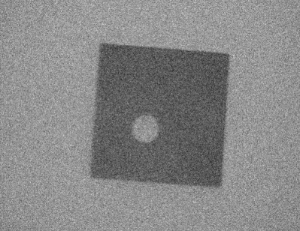
(a)
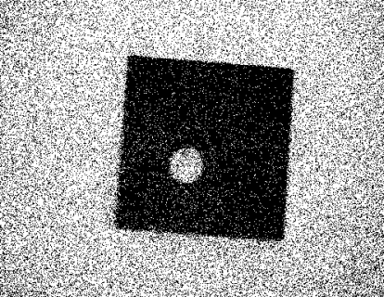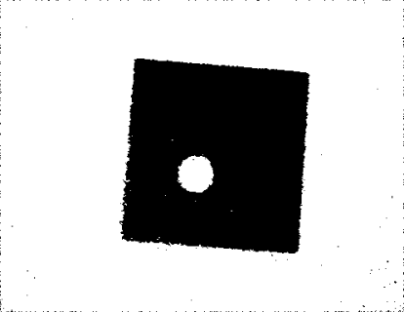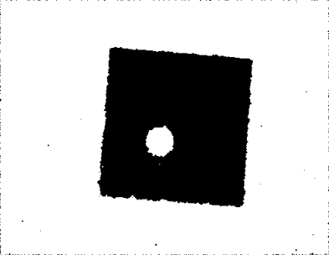
(b) (c) (d)
Fig 7. (a) test image 3, (b) segmentation image using HAF, (c) segmentation image using the proposed method with 3×3 mean filter, (d) segmentation image sing proposed method with the 3×3 median filter.

4.3 The Second Example
In the second example, three blood images: 1, 2, and 3, are generated through adding Gaussian white noise and salt and pepper noise to the blood image shown in figure 8. The mean value and standard deviation of Gaussian white noise for blood images 1, 2, and 3 are {0, 0.01}, {0, 0.02} and {0, 0.03}. The noise density of salt and pepper noise for blood images 1, 2, and 3 are 0.05, 0.06 and 0.07. The PSNRs of blood images 1, 2, and 3 are 15.6 dB, 13.9 dB, and 12.8 dB, respectively. From figures 9 to 11, the segmented images of blood images 1, 2, and 3 using the proposed method and HAF are presented. Table 2 shows the percentages of error for segmented results of blood images 1, 2 and 3 using the proposed method and HAF. From table 2, we can conclude that compared with HAF, the percentages of error for the segmented result of blood image 1, 2 and 3 using proposed method is lower than HAF. Compared with HAF, the proposed method with median filter can decrease the percentages of error for the segmented result of blood image 1, 2 and 3 by 68.2%, 71.1% and 74.2%, respectively.

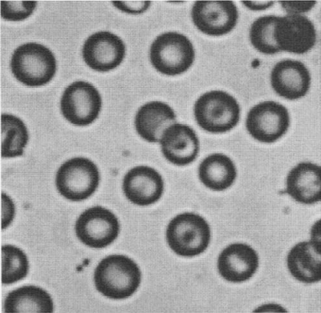
Fig 8. blood image.

TABLE 2: percentage of error of blood image
 | blood image 1  (PSNR = 15.6) | blood imaged 2  (PSNR = 13.9) | blood image 3  (PSNR = 12.8)
Histogram adaptive fuzzification | 6.5505% | 9.0710% | 11.9687%
Proposed method with  3×3 mean filter | 1.8152% | 2.1746% | 2.5275%
Proposed method with  3×3 median filter | 2.0844% | 2.6247% | 3.0927%

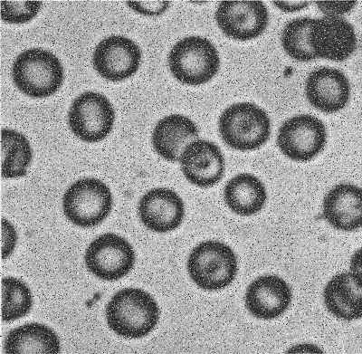
(a)
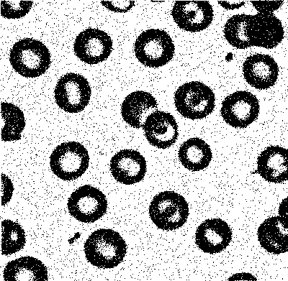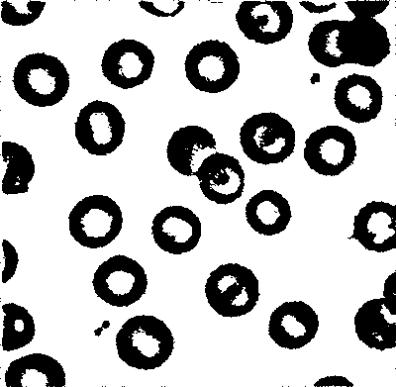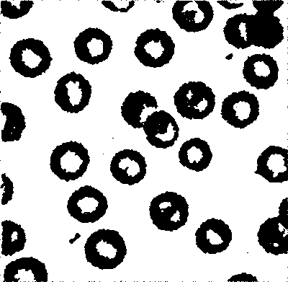
(b) (c) (d)
Fig 9. (a) blood image 1, (b) segmentation image using HAF, (c) segmentation image using the proposed method with 3×3 mean filter, (d) segmentation image using proposed method with the 3×3 median filter.
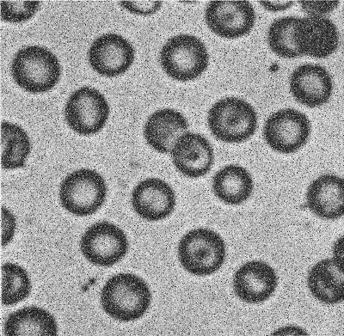
(a)
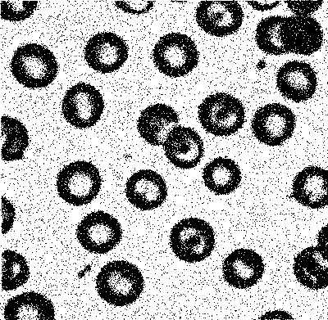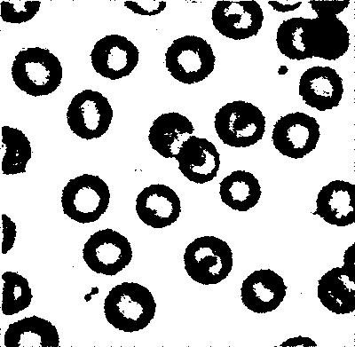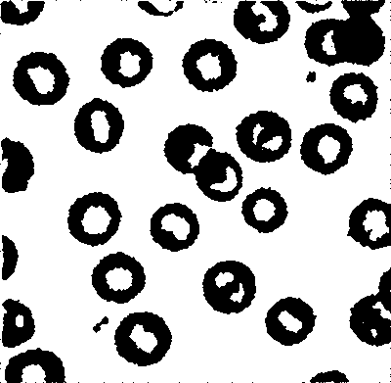
(b) (c) (d)
Fig 10. (a) blood image 2, (b) segmentation image using HAF, (c) segmentation image using the proposed method with 3×3 mean filter, (d) segmentation image using proposed method with the 3×3 median filter.
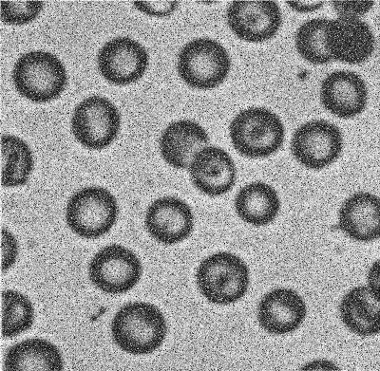
(a)
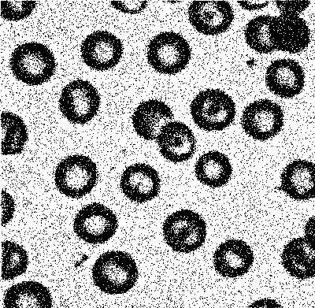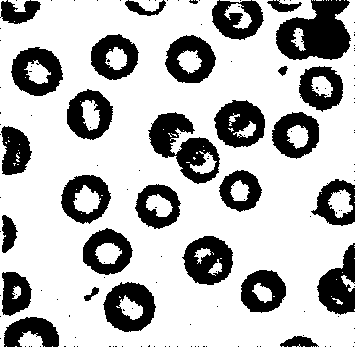
(b) (c) (d)
Fig 11. (a) blood image 3, (b) segmentation image using HAF, (c) segmentation image using the proposed method with 3×3 mean filter, (d) segmentation image using proposed method with the 3×3 median filter.

4.4 The Third Example
In the third example, three bacteria images: 1, 2, and 3, are generated through adding Gaussian white noise and salt and pepper noise to the bacteria image shown in figure 12. The mean value and standard deviation of Gaussian white noise for bacteria images 1, 2, and 3 are {0, 0.01}, {0, 0.02} and {0, 0.03}. The noise density of salt and pepper noise for bacteria images 1, 2, and 3 are 0.05, 0.06 and 0.07. The PSNRs of bacteria images 1, 2, and 3 are 17.3 dB, 15.5 dB, and 14.4 dB, respectively. The segmented images of bacteria images 1, 2, and 3 using the proposed method and HAF are presented in figures 9, 10, and 11, respectively. From these figures, we can also find that HAF obtains the worst segmentation images and the proposed with 3×3 median filter has the best segmentation results. Table 3 presents the percentages of error for segmented results of bacteria images 1, 2 and 3 using the proposed method and HAF. From table 3, we can find that the percentage of error for the segmented result of bacteria 3 using proposed method is pretty low (about 2.1%) due to the proposed method uses the spatial information of pixels. Compared with HAF, the proposed method with median filter can decrease the percentages of error for the segmented result of bacteria images 1, 2 and 3 by 81.3%, 84.5% and 87.0%, respectively.

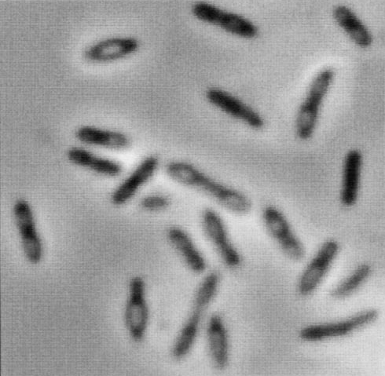
Fig 12. bacteria image.

TABLE 3: percentage of error of bacteria image
 | Bacteria image 1  (PSNR = 17.3) | Bacteria imaged 2  (PSNR = 15.5) | Bacteria image 3  (PSNR = 14.4)
Histogram adaptive fuzzification | 7.3205% | 11.9756% | 16.2234%
Proposed method with  3×3 mean filter | 1.3276% | 1.7204% | 2.2377%
Proposed method with  3×3 median filter | 1.3681% | 1.8235% | 2.1043%

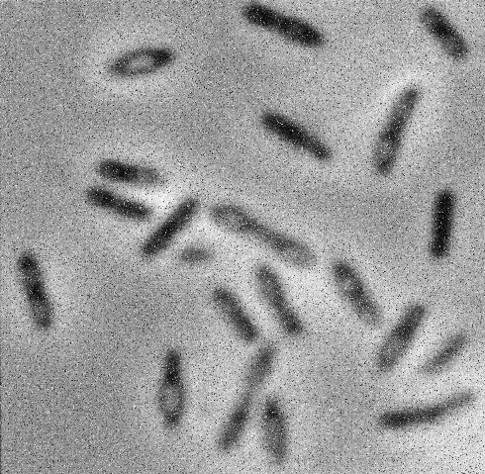
(a)
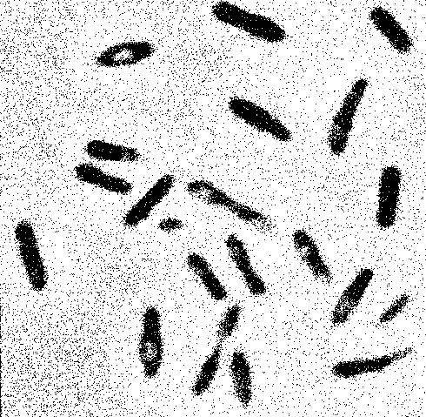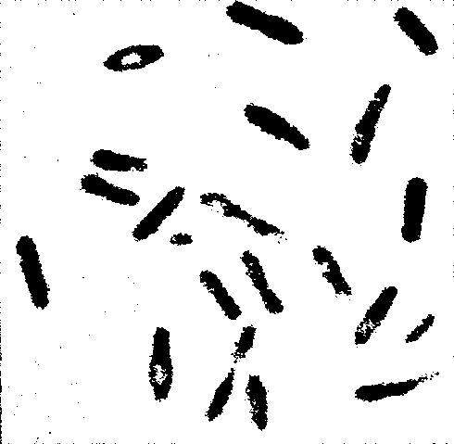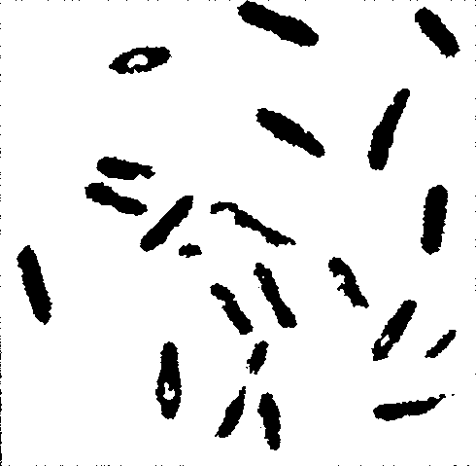
(b) (c) (d)
Fig 13. (a) bacteria image 1, (b) segmentation image using HAF, (c) segmentation image using the proposed method with 3×3 mean filter, (d) segmentation image using proposed method with the 3×3 median filter.
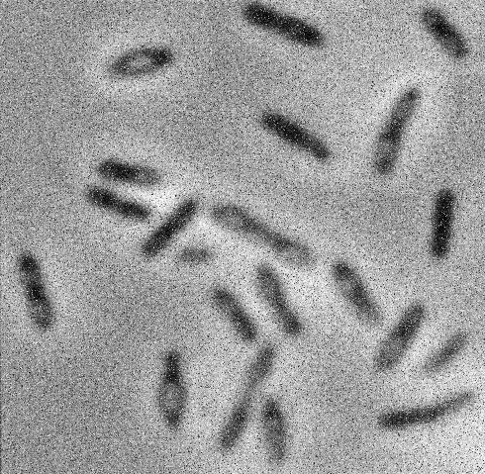
(a)
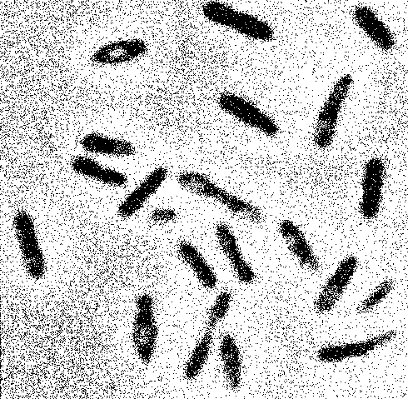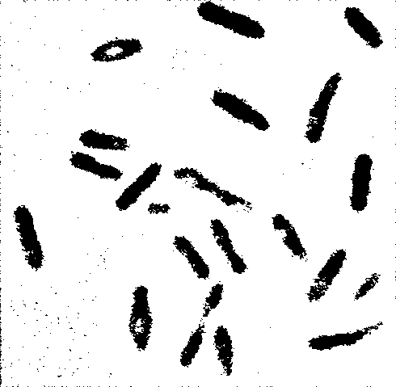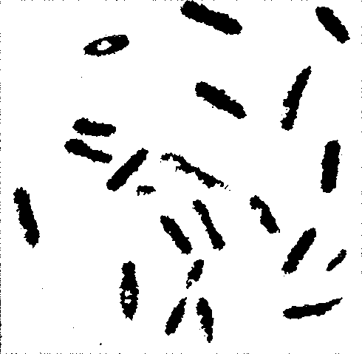
(b) (c) (d)
Fig 14. (a) bacteria image 2, (b) segmentation image using HAF, (c) segmentation image using the proposed method with 3×3 mean filter, (d) segmentation image using proposed method with the 3×3 median filter.
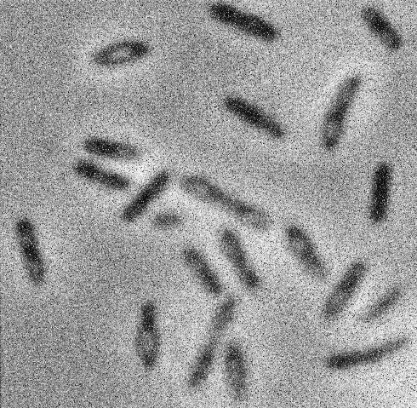
(a)
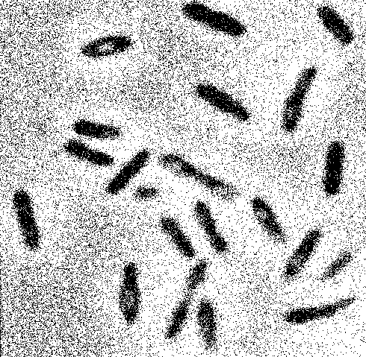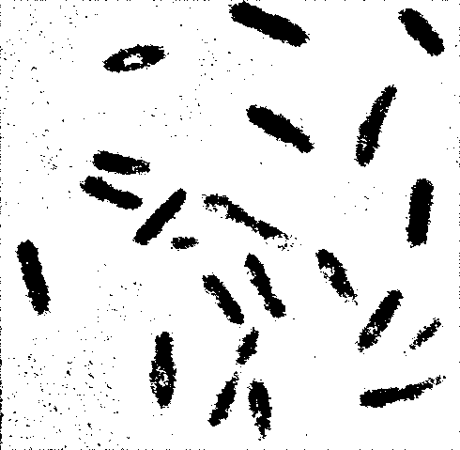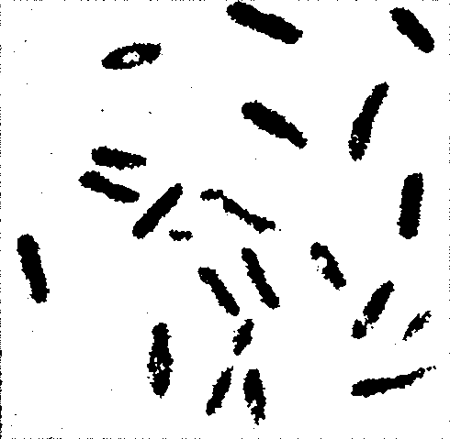
(b) (c) (d)
Fig 15. (a) bacteria image 3, (b) segmentation image using HAF, (c) segmentation image using the proposed method with 3×3 mean filter, (d) segmentation image using proposed method with the 3×3 median filter.

Chapter 5 Conclusion

In this thesis, we have presented an algorithm for image segmentation. The proposed algorithm uses fuzzy subsets to determine a threshold, which is used to segment an image into background and object regions. Similar to HAF (histogram adaptive fuzzification), the proposed method is not based on minimizing a cost function to determination the segmentation threshold. Due to HAF will obtain a bad segmentation result for a noisy image, the proposed method applies the 3×3 mean or median filter to a noisy image to improve image quality. Unlike HAF, the parameters x_{i} and x_{j} used to initialize subsets O and B are generated automatically, which release the burden of users to determine x_{i} and x_{j}. Compared with HAF, the proposed method can improve the segmentation result significantly when an image with bad quality is used. Compare with HAF, the proposed method with median filter can reduce the percentage of error by about 92% to 95% while we input reference image.

REFERENCES
[1] Rajen B. Bhatt, “Image Segmentation by Histogram Adaptive Fuzzification,” IEEE Indicon Conference, Chennai, India, 11-13 Dec. (2005).
[2] Recognition system, http://en.wikipedia.org/wiki/Face_recognition
[3] Fingerprint recognition, http://en.wikipedia.org/wiki/Fingerprint_recognition
[4] R. L. Cannon, J. C. Dave and J. C. Bezdek, “Segmentation of a thematic mapper image using the fuzzy c-means clustering algorithm,” IEEE Trans. on Geoscience and Remote Sensing, Vol. GRS-24, pp. 400-408 (1986).
[5] F. Wang, “Fuzzy classification of remote sensing images,” IEEE Trans. on Geoscience and Remote Sensing, Vol. 28, pp. 194-201 (1990).
[6] N. Otsu, “A threshold selection method from gray-level histograms,” IEEE Trans. Syst, Man, and Cybernetics, vol. SMC-9, no. 1, pp. 62–66, 1979.
[7] Ghosh, N. R. Pal and S. K. Pal, “Self-organization for object extraction using a multilayer neural network and fuzziness measure,” IEEE Trans. Fuzzy Systems, Vol. 1, No. 1, pp. 54-68 (1993).
[8] S. K. Pal, R. A. King and A. A. Hashim, “Automatic gray level thresholding through index of fuzziness and entropy, ” Pattern Recognition Letters, Vol. l, No. 3, pp. 141-146 (1983).
[9] Facial L. A. Zadeh, “Fuzzy sets,” Information and Control, Vol. 8, No. 3, pp. 338, 353 (1965).
[10] O. J. Tobias and R. Seara, “Image segmentation by histogram thresholding using fuzzy sets,” IEEE Trans. Image Processing, Vol. 11, No. 12, pp. 1457-1465 (2002).

